Experiment No.: 7
1.Title: Perform DOM traversal and updates; develop a to-do list app with add, edit, and delete features.
2. Software/Tools Required: VSC,HTML,CSS
3. Theory: DOM traversal allows JavaScript to select and navigate HTML elements, while DOM manipulation allows adding, editing, and deleting elements dynamically. A To-Do List uses these concepts to add new tasks, edit existing tasks, and delete completed or unwanted tasks without reloading the webpage.
4.Output:
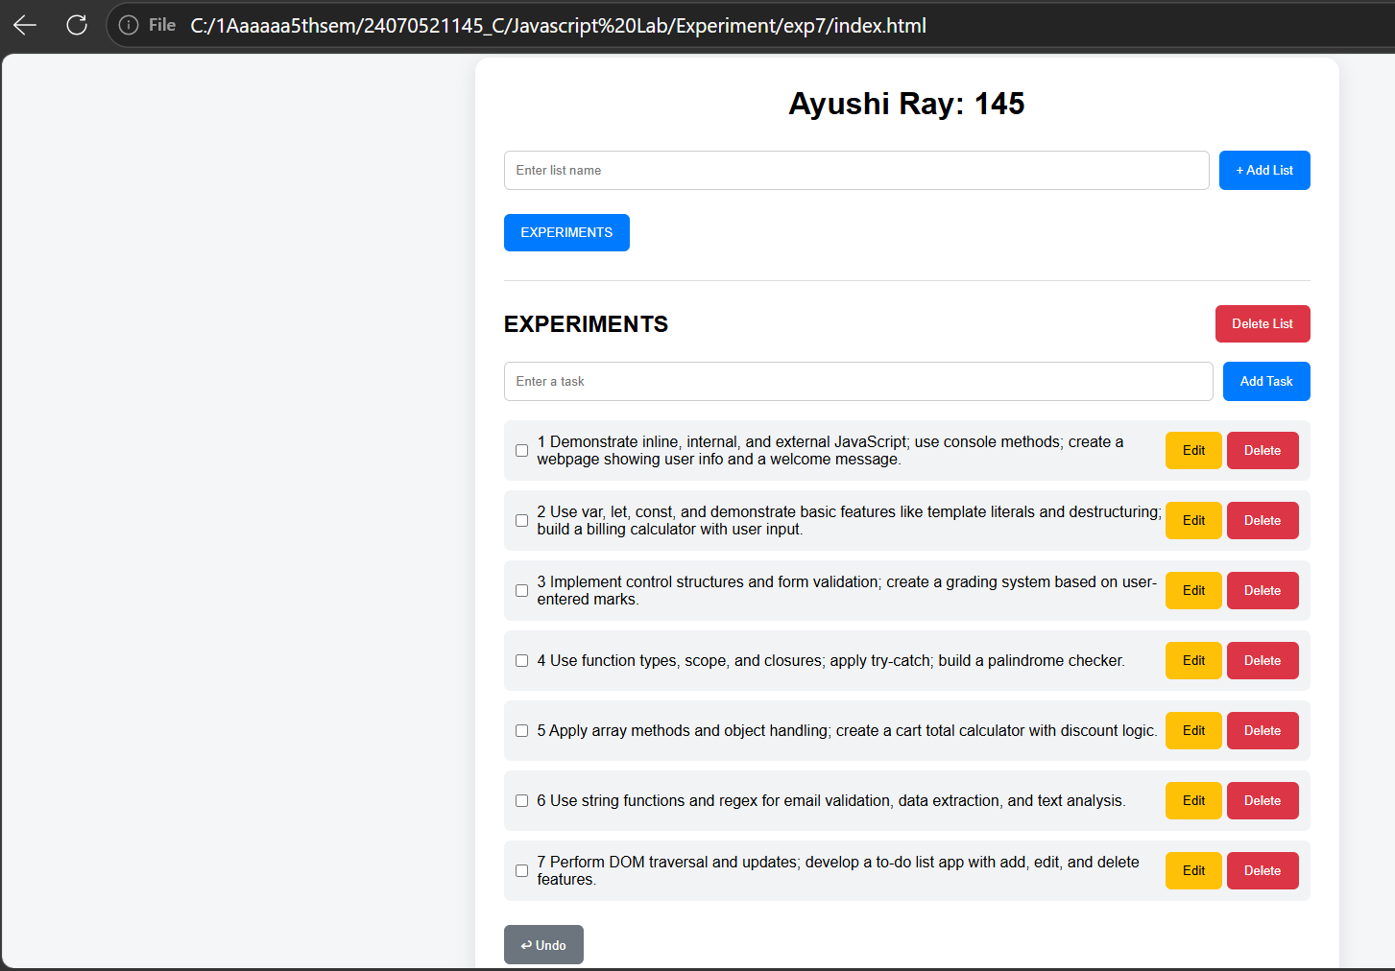
5.Result: The shopping cart application was successfully developed using HTML, CSS, and JavaScript. It provides an interactive e-commerce interface where users can browse products, search items, add or remove products, modify quantities, and view the cart summary. The application dynamically calculates the total amount, applicable discount, and final payable amount using JavaScript array methods and object handling.

